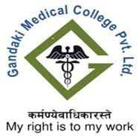
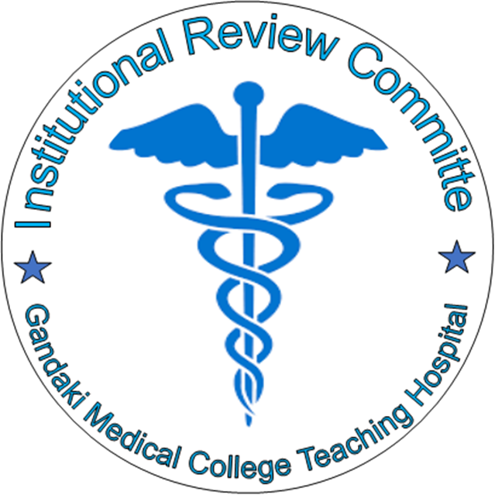

Gandaki Medical College Teaching Hospital and
Research Center
Institutional Review Committee
Pokhara Lekhnath, Kaski
Phone – +977-61-561718 E-mail: gmcirc2019@gmail.com
Website –http://www.gmc.edu.np
Research Proposal Application Format

Research Title:

For Official Use Only

(Please see the check list before Registration of the application form)

Registration No:
Registration Date:
Approval Date:
Name of Principal Investigator:
Research Site:
Total Budget of the Project (In words):
Tentative Date of Initiation of the Research Project:
Duration of the Research Project:
Signature and seal of GMC-IRC:
PART-I
Administrative Information
- Research Title:

- Name and Address of Principal Investigator (PI): (full CV should be attached)
Title (Mr. / Ms. / Dr.) :
First Name:
Middle Name (if any):
Last Name:
Nationality:
Designation:
Postal Address:
Telephone No.:
Mobile No.:
Fax No.:
E-mail:
Alternative E-mail:
- Institutional Details of PI :
Full Name of Institution:
Postal Address:
Telephone No.:
Fax No.:
Email:
Website:

- Name and Address of Co-investigator/s (if any) :
Title (Mr. / Ms. / Dr.) :
First Name:
Middle name (if any):
Last Name:
Nationality:
Designation:
Postal Address:
Mobile No.:
E-mail:
(Use similar format and additional sheet if more than one)
- Institutional Details of Co-investigator/s:
Full Name of Institution:
Postal Address:
Telephone No.:
Fax No.:
Email:
Website:
(Use similar format and additional sheet if more than one)

- Is this research part of your thesis? (√ )
Yes No

If yes,
For what Degree and in which subject?
Name of Institution:
Name of University:

PART-II
Financial Information
- Name and Address of Funding Organization:
Full Name of Institution/ Organization:
Postal Address:
Telephone No.:
Fax No.:
Email:
Website:
- Budget details:
Total budget of the Research (In words):

Itemized budget details of the Research: (Use additional Sheet if required)

PART-III
Research Proposal Description

- Research Title:

- Introduction:
Background of the study (max. 250 words):

- Proposal Summary (max. 250 words):

- Statement of the Problem and Rationale (max. 250 words):

- Conceptual Framework:

- Research Objective/s:
General Objective/s:

Specific Objective/s:

- Research Design and Methodology (√ ) :

7.1 Research Method: I. Qualitative II. Quantitative III. Combined

  - Type of study:
  - Study Variables:
Dependent Variables:

Independent Variables:

7.4. Study site and its justification:

7.5. Study Population (verify):

7.6. Criteria for sample selection (Inclusion criteria):

7.7. Criteria for sample rejection (Exclusion criteria):

7.8. Data collection Method/s /Technique/s:

7.9. Data collection tools:

7.10. Pretesting of the data collection tools (if applicable):

7.11. Validation and reliability of the study tool:

7.12. Data management and analysis tools:

7.13. Expected Outcome/s:

7.14. Plan for dissemination of the Research result/s:

7.15. Plan for application of the research results (if any):

7.16. Work Plan (Should include duration of the study, tentative date of starting of the project and details of work schedule in the form of Gantt chart):

PART-IV
Ethical Considerations
- Regarding the human participants:
1.1. Are human participants required in this research?
Yes No

1.2. How many participants are required for the research? Explain in brief.

1.3. What is the frequency of the participant's involvement in the research? Explain in brief.

1.4. Clearly mention the responsibilities of the participants in the Research.

1.5. Are vulnerable members of the population required for the research? If yes, justify.

1.6. Are there any risks involved for the participants? If yes, clearly mention.

1.7. Are there any direct benefit involved for the participants? If yes, clearly mention.

- Regarding the Animal Objects:
2.1. Are animal objects required in this research? If yes, why?
Yes (Provide justification) No

2.2. What animal and how many animals are required for the research?

2.2. What procedures are done on the involved animals? Mention it clearly.

2.3 Is the use of the animal protected by local or government rule?

Yes No

- Informed Consent Form:
Statements required in the Informed Consent Form include:
  - A statement that the human participants can withdraw from the study at any time without giving reason and without fear. State clearly how the participants can opt out the study.

  - A statement guaranteeing the confidentiality of the research participants.

  - If required, a statement on any compensation that might be given to the research participant and or their community.

  - A statement indicating that the participant has understood all the information in the consent form and is willing to volunteer / participate in the research.

  - Signature space for the research participants, a witness, and the date.

More about informed consent:

Describe the manner in which informed consent will be obtained.

If the subjects are children/adolescents ages 7 to 18 years, an Assent Form must be included with the GMC-IRC application. The signed Assent Form along with the Guardian Consent Form must be retained on file for at least three years after completion of the research project.

If prisoners / pregnant women, or fetuses are to be included in the research, it is likely that a more intense GMC-IRC review is required and additional human subjects' protections will be expected.

The Informed Consent form must be written at a level that the subjects will understand. Please use simple language, and avoid clinical jargon.

If the subjects do not read or comprehend English or Nepali, you must provide a consent form in their language as well as in English for GMC-IRC review and approval.

When you are requesting a consent from the subjects, you MUST justify the request by providing an elaborated explanation of why obtaining written consent and should explain the risks to the subjects and your provisions for informing them about the study.

You will have to provide any other relevant information if necessary. Please be aware that the PI is legally required to retain all signed Informed Consent forms for at least three years after the project terminates.

Attach a copy of the written informed consent form where applicable.

Consent documents MUST be in the same format requested/ approved.

If the study uses database or archival data, the use of informed consent is not applicable.

Indicate the extent to which confidentiality of records identifying subjects will be maintained.

3.1. Obtaining the consent:
How informed consent is obtained from the research participants?
Verbal Written

Indicate the full Name who is responsible for obtaining informed consent from the participants in the Research?

Is the research sensitive to the Nepali culture and the social values? If yes, mention.

Yes No

Is any insurance/ compensation is made to the research participants? If yes, please provide the necessary information and mention in consent form also.

Yes No

PART-V
Acceptance of General Considerations and Declaration by the Principal Investigator

I hereby certify that the above mentioned statements are true. I have read and understood the rules and regulations of the Nepal Health Research Council (NHRC) and Institutional Review Committee of Gandaki Medical College (GMC-IRC) for approval of research proposal and will act in conformity with the said regulations in all aspects.

If my research is terminated, for any reason, I will notify GMC- IRC of the decision and provide the reasons for such actions. I will provide reports and progress of research to the GMC-IRC committee when requested. I will provide GMC-IRC a written notice upon the completion of the research as well as a full report or final summary of the research study. If I publish the results in any journal, I shall acknowledge the GMC-IRC and shall provide a copy of any such articles.

.........................................
Signature of the Applicant
Full Name:
Date:

PART-VI
References

Check List
For all applicants:

- Cover letter addressed to the Member Secretary indicating the submission of the approval of proposal.
- Proposal in GMC-IRC format.
- Submission of both printed and electronic version of the proposal.
- Brief introduction and address of the Principal Investigator & Co-Investigator/s.
- Institutional addresses of the Principal Investigator & Co-Investigator/s.
- CV of Principal Investigator.
- Source of funding (if any) for the proposed project.
- Full address of funding agency.
- If the research study is to be conducted in any hospitals/organization or institution/community, a letter of approval from the related hospital/organization or institution/district.
- Research proposal description.
- Data collection tools in Nepali & local language (if necessary).
- Work plan in the form of Gantt chart.
- Consent form should be in English and Nepali or local language (if necessary).
- Signature of PI in Acceptance of General Considerations and Declaration form.
- Referencing style in Vancouver style.

For student’s applications:
- CV of Academic Supervisor.
- Recommendation letter from Academic Supervisor.
- Approval letter from concerned Institute/University.

